Project Name: Find a Pump
Sprint Duration: February 16 – March 22, 2026
Sprint Goals: Implement automated unit testing, address customer feedback
Team Name: Gas Guzzlers
Team Members:
Eric Parral, Nathan Carlson, Kyler Cressall, and Thomas Ross
Prepared by: Eric Parral (Team Lead)
Date Submitted: March 22, 2026

Project Description
Overview and Justification
Find a Pump is a web-based application that strives to help users find the gas station with the cheapest gas near them in Utah County. To help users find a pump that fits their needs, they will be able to filter the results by type of gas (diesel or regular), quality, or even find an EV charger. Users will be able to add in any discounts they receive at specific gas stations to be factored in automatically for them. They will also be able to modify the search area, which will allow them to choose how far they are willing to go for the cheapest gas.
Find a Pump aims to alleviate the pain points of constantly fluctuating gas prices and the current inflation problem by providing users with the latest price information available. This will take the stress out of spending too much money on gas and remove the uncertainty of what the price will be. Utah County is full of college-aged adults who typically have tight budgets and do not have the ability to spend frivolously. Providing them with the cheapest gas options will allow them to enjoy their time and use their money where it matters more fully.
Tech Stack and Measuring Success
The application will integrate Google Maps APIs to provide accurate geolocation and redirect Google Maps to get turn-by-turn directions. A responsive frontend with React will display station distance and current fuel or charging prices. The backend, powered by Node.js with Express, will manage API requests, data aggregation, and communication with external APIs. A local SQLite database will store station metadata, user preferences, and cached results to improve performance. Then for the data processing the application will use JavaScript for the caching and aggregation. Together, this tech stack creates a scalable, intuitive, and reliable application that enhances everyday travel planning.
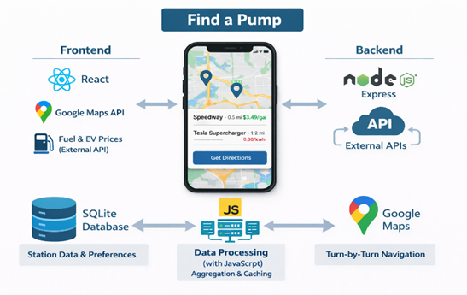
The application is complete once it has met its core functionality goals, reliably retrieving and displaying nearby stations with accurate distance and pricing information. Verifying that the Google Maps redirection works consistently, ensuring seamless navigation for users. From a UI/UX perspective, the interface is clean, responsive, and intuitive, while map interactions such as zooming, panning, and marker selection feel natural. If launched, the shipped version will demonstrate powerful performance, with average API response times under five hundred milliseconds and map and station data loading within two seconds. The user engagement metrics should indicate healthy adoption, reflected in steady daily active users and frequent station lookups per session. Lastly, in terms of reliability, the application maintains 99% uptime over a 7-day period, with API error rates kept below 5%.
API Research
To power our app, it will need live, accurate price data for the different fuel types at gas stations across Utah County. The best way to do this is to use an existing API, which hosts this live data already. One example of an API the application could use is like the one hosted at “ww.oilpriceapi.com,” which can give the real-time prices of fuel at each station filtered by latitude and longitude coordinates with a radius around it. This data will include the prices of the fuel at each station for us to use to display and sort.
To get accurate live data of these prices, when the user opens the app, it will get data from the API. That can store it in the app database to display prices on the map. If a user launches the app again offline or if the API is down, it will use the existing prices in the database to continue to display information. Storing the data from the API in our own database will limit the number of times the API is called, as well as give us more flexibility for querying and displaying the data.
Google Maps API is what will power the geospatial mapping portion of the application. It allows us to use JavaScript to create a live map pulling from Google Maps and then be able to add many pins/markers on the map as needed. This streamlines the process, so all that will need to be done to implement it is to create an API in our backend to query each of the station’s coordinates and prices, then iterate through them, placing them on the map.
Potential Features and Stakeholders
This application is designed to help consumers in Utah County quickly locate nearby gas stations and compare fuel prices in their area. Using the user’s current location, the system will display gas stations on an interactive map or in a list-based view, allowing users to easily identify both the closest and the cheapest options available. Key features include location-based search, fuel price displays for multiple fuel types, distance indicators showing how far each station is from the user, and sorting or filtering options that allow users to prioritize proximity or cost. These features are intended to save users time, reduce fuel expenses, and simplify the decision-making process when choosing where to refuel.
The primary stakeholders of this system are drivers in Utah County who directly benefit from easy access to nearby gas station locations and fuel price comparisons. Secondary stakeholders include gas station owners, who may experience increased visibility and customer traffic when their stations appear competitive options within the application, as well as third-party API and data providers that supply the location and pricing information used by the system. Indirect stakeholders include members of the local community, who may benefit from reduced unnecessary driving, and the development team. Those who are responsible for ensuring the system remain dependable, accurate, and user-friendly.

Software Requirements Specification (SRS)
Functional Requirements
1.1 Core Display (FR-CD)
FR-CD-1: The system shall automatically detect the user’s geographic location using the device’s location services with the user’s permission.
FR-CD-2: The system shall allow users to manually input a geographic location by entering a city, address, or ZIP code.
FR-CD-3: The system shall display gas stations located within a default radius of exactly 5 miles of the user’s detected or manually entered geographic location. Users shall be able to modify the search radius to any value between 1 mile and 25 miles, adjustable in 1-mile increments.
FR-CD-4: The system shall represent each fuel station as a distinct marker displayed on the map interface at the station’s geographic coordinates.
FR-CD-5: When a map marker is selected, the system shall display a summary containing the station name and at least one available fuel price.
FR-CD-6: The system shall display the available fuel types for each station, explicitly limited to regular, mid-grade, premium, and diesel, when such data exists.
FR-CD-7: The system shall display the current price for each available fuel type at a selected station.
FR-CD-8: When the EV filter is enabled, the system shall display indicators identifying stations with electric vehicle (EV) charging availability.
FR-CD-9: When a fuel station is selected, the system shall display detailed station information, including station name, street address, distance from the user (in miles), available fuel types, fuel prices, and the timestamp indicating when pricing data was last updated, when such data is available.
FR-CD-9a: If one or more station detail fields are unavailable, the system shall display “Data unavailable” for each missing field while continuing to display all remaining available information.
FR-CD-10: The system shall include the station’s street address in the detailed station view whenever address data is available.
FR-CD-11: The system shall provide a selectable link that opens turn-by-turn navigation to the selected station in Google Maps.
FR-CD-12: The system shall display a timestamp indicating the last update time of the station’s fuel pricing data.

1.2 Search and Filtering (FR-SF)
FR-SF-1: The system shall display nearby fuel stations in a list view showing station name, distance from the user, and at least one fuel price per station.
FR-SF-2: The system shall allow users to toggle between a map-based view and a list-based view at any time without reloading the application.
FR-SF-3: The system shall update search and filter results within 1 second after the user modifies any search criteria, including distance, fuel type, or price filters.
FR-SF-4: The system shall allow users to filter displayed stations based on fuel price thresholds.
FR-SF-5: The system shall allow users to select a preferred fuel type, which shall influence both filtering and sorting behavior.
FR-SF-6: The system shall prioritize and sort displayed stations based on explicitly selected criteria, including fuel price in ascending order, distance in ascending order, or availability of the preferred fuel type.
FR-SF-7: The system shall allow users to input discount programs associated with specific fuel stations.
FR-SF-8: The system shall store user-defined discount program information for future application.
FR-SF-9: The system shall automatically apply stored discount programs to displayed fuel prices when applicable.
FR-SF-10: The system shall allow users to update existing discount program entries.
FR-SF-11: The system shall allow users to delete previously stored discount program entries.

1.3 Data Handling (FR-DH)
FR-DH-1: The system shall locally cache retrieved fuel price data to reduce repeated external API requests.
FR-DH-2: The system shall retrieve and display cached fuel price data when external API services are unavailable.
FR-DH-3: The system shall retrieve and display cached fuel price data when the user’s device is offline.
FR-DH-4: When an internet connection is available, the system shall automatically refresh cached fuel price data without requiring user intervention.
FR-DH-5: The system shall associate a timestamp with all cached data indicating when the data was last retrieved.
FR-DH-6: The system shall display timestamps alongside all pricing data presented to the user.
.

1.4 Error Handling (FR-EH)
FR-EH-1: The system shall display an error message if user location cannot be determined.
FR-EH-1: If the user’s geographic location cannot be determined, the system shall display a clear error message explaining the issue and requesting manual location input.
FR-EH-2: When no stations match the user’s selected filters, the system shall display a message indicating that no matching results were found.
FR-EH-3: If an external API request fails, the system shall display an error message informing the user of the failure.
FR-EH-4: When live data retrieval fails, the system shall display cached data if available.
FR-EH-5: The system shall continue to function and display available information when partial or incomplete station data is returned and shall not crash due to missing data fields.

Non-Functional Requirements
2.1 Performance (NFR-PR)
NFR-PR-1: The system shall return external API responses within 500 milliseconds on average under normal operating conditions.
NFR-PR-2: The system shall load map and station data within 2 seconds of initiating a search.
NFR-PR-3: The system shall update search and filter results within 1 second of user input.
NFR-PR-4: The system shall support at least 500 concurrent users without degradation of core functionality.
NFR-PR-5: Cached data retrieval operations shall complete within 200 milliseconds.

2.2 Reliability and Availability (NFR-RA)
NFR-RA-1: The system shall maintain 99% uptime over any 7-day continuous period.
NFR-RA-2: The system shall automatically recover from system crashes within 60 seconds.
NFR-RA-3: The system shall provide fallback functionality using cached data when live data is unavailable.
NFR-RA-4: The system shall synchronize cached data after recovering from system downtime.
NFR-RA-5: The system shall handle external API failures without terminating user sessions or crashing.

2.3 Usability and User Experience (NFR-UX)
NFR-UX-1: The system shall present a user interface that enables task completion without requiring external documentation.
NFR-UX-2: Users shall be able to access all core features within three user interactions.
NFR-UX-3: The system shall support responsive design for both desktop and mobile devices.
NFR-UX-4: The system shall display clear visual indicators representing fuel stations on the map.
NFR-UX-5: The system shall display loading indicators while data is being retrieved.
NFR-UX-6: The system shall display error messages using clear, user-friendly language with suggested corrective actions.

2.4 Scalability (NFR-SC)
NFR-SC-1: The system shall support geographic expansion to new regions without requiring major architectural changes.
NFR-SC-2: The backend shall support horizontal scaling to accommodate increased demand.
NFR-SC-3: The database shall efficiently handle datasets containing one million records or more.
NFR-SC-4: Sensitive configuration values shall not be hardcoded and shall be stored securely.

2.5 Security (NFR-SE)
NFR-SE-1: The system shall securely store API keys using environment variables or a secrets management solution.
NFR-SE-2: The system shall validate all user inputs to prevent invalid or malicious data entry.
NFR-SE-3: The system shall implement API rate limiting to prevent abuse.

2.6 Maintainability (NFR-MA)
NFR-MA-1: The system shall follow modular design principles to isolate functionality.
NFR-MA-2: The system shall include up-to-date developer documentation.
NFR-MA-3: The system shall support automated testing of functional components.
NFR-MA-4: The system shall use version control for all source code.
NFR-MA-5: The system shall enforce consistent coding standards across all modules.

2.7 Portability and Compatibility (NFR-PC)
NFR-PC-1: The system shall function correctly on the latest versions of Chrome, Firefox, Safari, and Edge.
NFR-PC-2: The system shall support multiple operating systems.
NFR-PC-3: The system shall adapt its layout to different screen sizes.
NFR-PC-4: The system shall not require browser-specific plugins.

2.8 Data Accuracy and Integrity (NFR-DI)
NFR-DI-1: The system shall validate all external API data before storing it locally.
NFR-DI-2: All stored data shall include timestamps indicating when the data was retrieved.
NFR-DI-3: The system shall prevent duplicate records from being stored.
NFR-DI-4: Cached data shall be refreshed at least once every 24 hours.
NFR-DI-5: The system shall clearly indicate when displayed data may be outdated.

2.9 Accessibility (NFR-AC)
NFR-AC-1: The system shall comply with WCAG 2.1 Level AA accessibility standards.
NFR-AC-2: The system shall support full keyboard navigation.
NFR-AC-3: The system shall be compatible with screen readers.
NFR-AC-4: The system shall provide a high-contrast display mode.
NFR-AC-5: All interactive elements shall include descriptive labels or ARIA attributes.

2.10 Logging and Monitoring (NFR-LM)
NFR-LM-1: The system shall log all system-level errors.
NFR-LM-2: The system shall monitor external API usage.
NFR-LM-3: The system shall record performance metrics.
NFR-LM-4: The system shall notify administrators of critical failures.
NFR-LM-5: All logs shall include timestamps and severity levels.

2.11 Backup and Recovery (NFR-BR)
NFR-BR-1: The system shall perform database backups daily.
NFR-BR-2: The system shall verify the integrity of backups weekly.
NFR-BR-3: The system shall support full data restoration from backups.
NFR-BR-4: Backup data shall be stored securely.

2.12 Legal and Compliance (NFR-LC)
NFR-LC-1: The system shall comply with all Google Maps API usage and licensing policies.
NFR-LC-2: The system shall comply with fuel data provider licensing agreements.
NFR-LC-3: The system shall protect user privacy in accordance with applicable laws.
NFR-LC-4: The system shall provide a publicly accessible privacy policy.
NFR-LC-5: The system shall not store personally identifiable information without explicit user consent.
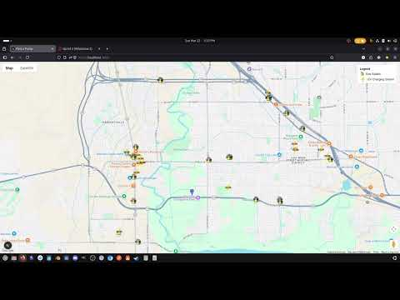
Prototype/ Demo Video
Source Code
Can be found at cs4400-findapump/find-a-pump-code at main · kylercressall/cs4400-findapump
Design
Architecture Diagram
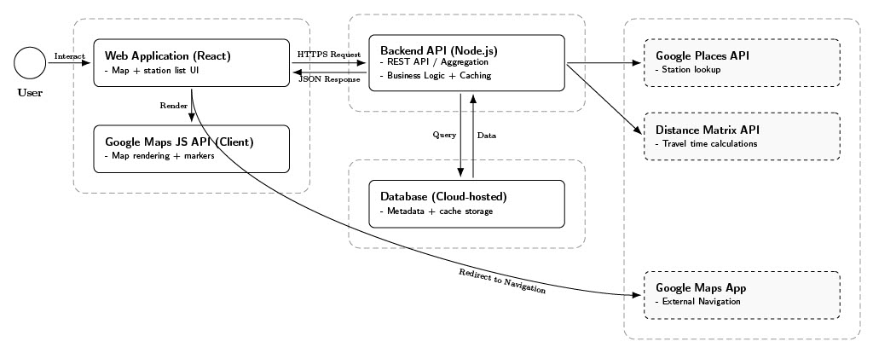
Table 1: https://github.com/kylercressall/cs4400-findapump/blob/main/documentation/UML/Architecture_diagram.pdf
This diagram illustrates the three-tier architecture of the Find A Pump system. The React frontend communicates with the Node.js Express backend via RESTful APIs. The backend integrates with external services including the Fuel Pricing API and Google Maps API. A SQLite database stores caught pricing data and user preferences. This design ensures separation of concerns and supports scalability.
Entity Relationship Diagram
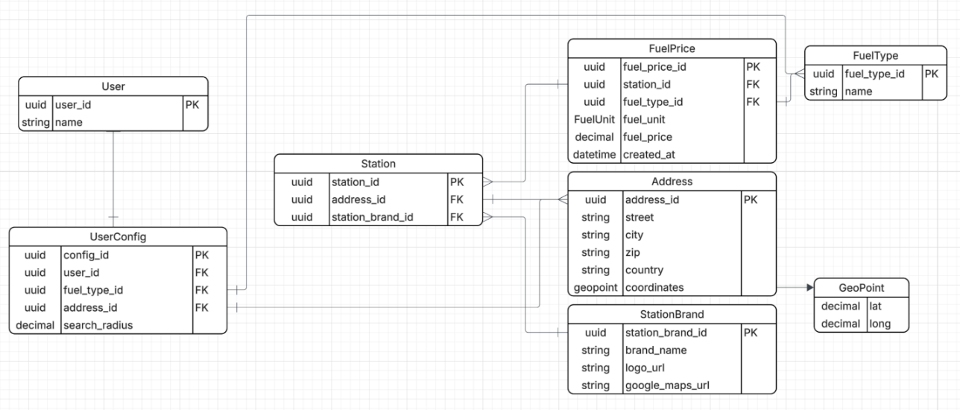
Table 2: https://github.com/kylercressall/cs4400-findapump/blob/main/documentation/UML/entity-relationship-diagram.png
The ER diagram defines relationships between Stations, Fuel Types, Prices, and User Preferences. Primary keys and foreign key constraints ensure data integrity. Timestamp fields are included to support caching validation.
Use Case Diagram
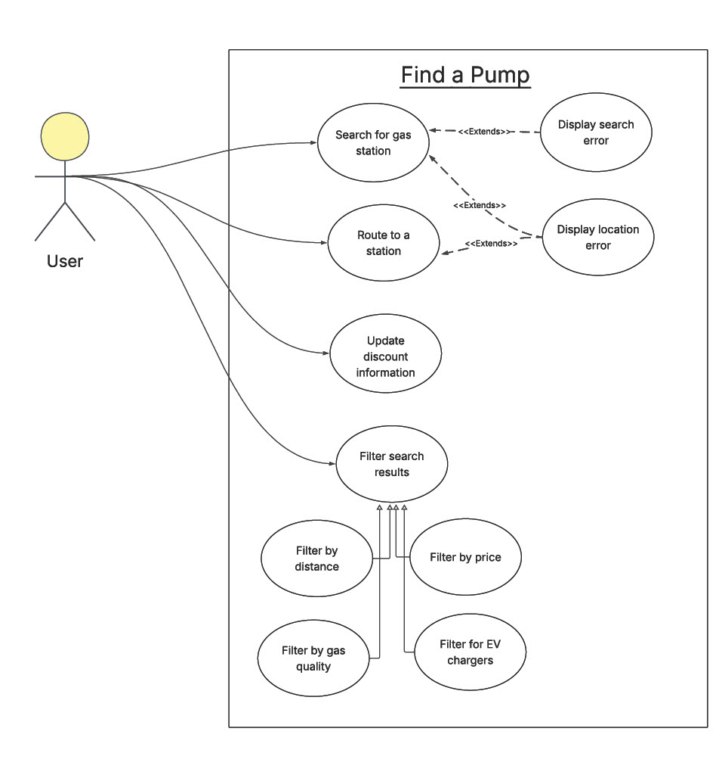
Table 3: https://github.com/kylercressall/cs4400-findapump/blob/main/documentation/UML/Find%20a%20Pump%20--%20Use%20Case%20Diagram.pdf
The use case diagram outlines 12 primary user interactions, including searching for stations, applying filters, entering discounts, viewing station details, and navigating via Google Maps. All use cases are maintained at the same abstraction level to ensure balanced granularity.

Class Diagram
Images can be found at cs4400-findapump/documentation/UML/class-diagrams-current-vs-srs.md at main · kylercressall/cs4400-findapump
Frontend Review Against Current Code
Implemented now:
- Homepage only renders MapView.
- MapView loads Google Maps, reads browser geolocation, searches nearby gas and EV stations, renders markers, and shows a simple error banner.
- Station, Lat, Long, and Station Kind exist as local TypeScript types in the map component.
Missing relative to the SRS:
- Manual location input.
- List view and map/list toggle.
- Distance, fuel type, and price filters.
- Marker selection summary and detailed station view.
- Fuel price display per station.
- Discount program CRUD and discount application.
- Offline caching and cached fallback behavior in the frontend.
- Explicit loading indicator component and accessibility-focused UI modules
Backend Review Against Current Code
Implemented now:
- Express app wiring with CORS and JSON middleware.
- Route, controller, and service separation for stations, maps, and prices.
- MapsService calls the Google Places API, returns nearby gas and EVstations, and asynchronously upserts station/location/brand cache data intoPrisma.
- StationService returns stations with Location, StationBrand, and sortedFuelPrice relations.
- Prisma entities exist for users, user config, fuel types, fuel prices, stations,locations, and brands.
- Basic automated tests exist for the frontend map component and the stationcontroller/service layers.
Partial or missing relative to the SRS:
- PriceService is still a stub and does not expose real pricing logic.
- No backend discount-program model or CRUD endpoints.
- No dedicated cache refresh scheduler, offline synchronization job, or stale-data policy.
- Input validation is limited to a few numeric query checks in MapsController; there is no shared validation middleware.
- No API rate limiting.
- Logging is ad hoc console logging plus a Google Maps API log file, not fullmonitoring/alerting.
- No backup/recovery module in the application code.
Customer Feedback
During Sprint 2, feedback focused primarily on improving the clarity, structure, and completeness of the project documentation, as well as strengthening the testing strategy. The following table maps customer and instructor feedback to explicit updates across system requirements, design artifacts, and testing to ensure full documentation traceability.
Feedback Issue Identified | Requirement(s) Updated | Design Impact | Test Coverage
Ambiguous definition of “nearby” | FR-CD-3 (Revised with mile radius) | Search radius control added to UI | Location radius filter tests
Non-measurable performance wording | FR-SF-3 aligned with NFR-PR-3 | Optimized filter execution | Performance and timing tests
Ambiguous “relevant results” language | FR-SF-6 (Explicit sorting criteria) | Defined backend sorting logic | Sorting validation test cases
Missing data behavior undefined | FR-CD-9a, FR-EH-5 | Station detail fallback states | Error-handling and API failure tests
These updates ensure that all feedback is explicitly traceable from requirements → design → implementation → testing, improving testability, clarity, and grading alignment.

1. Documentation Clarity and Structure
Feedback:
The report required improved clarity, organization, and stronger connections between sections.
Action Taken:
Added title page.
Numbered functional and non-functional requirements.
Redesigned class diagram to improve readability.
Broke down customer feedback into structured entries.
Explicitly linked feedback to functional requirements.
Added meeting logs and contribution forms to Appendices A and B, respectively.
Standardized naming conventions by ensuring full names are used consistently throughout the documentation.
Fixed all incorrect dates for backlog assignment and completion dates.
Impact:
Improved maintainability and alignment with software engineering documentation standards.
2. Testing Coverage and Implementation
Feedback:
Greater emphasis was needed on implementing and documenting testing for the system.
Action Taken:
Expanded unit and integration test coverage for both frontend components and backend APIs.
Improved test plan to include more detailed scenarios and coverage.
Ensured tests align with system requirements.
Ensured all currently implemented functional and non-functional requirements have associated test cases.
Impact:
Increased system reliability and better validation of core features. This also ensures traceability between functional and non-functional requirements and their corresponding test cases.
3. Carryover Feature Feedback (from Sprint 1)
The following feature-related feedback from Sprint 1 continues to guide development and will be incorporated into future iterations.
3.1. EV Charger Integration
Feedback:
The system should support displaying electric vehicle (EV) charging stations in addition to gas stations.
Interpretation:
Users may drive electric vehicles and require access to charging locations, expanding the system beyond traditional fuel types.
Action / Requirement:
Add support for EV charging station data in the backend.
Update map UI to display EV charging locations.
Introduce filtering options for fuel type (Gas vs EV).
Related Requirement:
FR-5: The system shall display EV charging station availability when the user enables the EV option.
3.2. Price Range Filtering
Feedback:
Users should be able to filter out gas stations that fall outside a selected price range.
Interpretation:
Users are primarily interested in affordable options and need a way to quickly exclude expensive stations.
Action / Requirement:
Implement a price range filter (min/max).
Update frontend UI with slider or input fields.
Modify backend queries to return only stations within range.
Related Requirement:
FR-9: The system shall allow users to filter displayed stations by fuel price
Testing Plan
Can we linked to cs4400-findapump/documentation/Testing Docs/Comprehensive Test Plan - Find A Pump.md at main · kylercressall/cs4400-findapump
Test Data:
A seeded station dataset with:
Multiple stations, fuel types, prices, and varied distances
Some missing or invalid API fields for validation tests
Discount programs matching specific stations
Cached snapshot with timestamps
Test Environment:
The testing environments will be finalized by the end of sprint 2. It will most likely include multiple browser types, device types, online and offline modes, and location services allowed and blocked.
Test Cases:
Test cases will be finalized by the end of sprint 2. They will cover the expected scope of the testing plan with pass/fail information included.
Pass/Fail Criteria:
Functional: 100% of functional test cases must pass.
Non-functional: Must meet defined thresholds
Any crash on common user flow is a fail.
Schedule:
This testing plan will be finalized by the end of sprint 2. The unit testing and integration testing will be performed in sprint 3. System testing and non-functional testing will be carried out in sprint number 4.
Quality Assurance Metrics
Design metric:
The design metric chosen for Find a Pump is high cohesion. This will be achieved by clearly dividing responsibilities and ensuring that each module has a single, well-defined purpose. High cohesion improves maintainability, makes the system easier to understand, and helps isolate defects, which in turn facilitates faster debugging and more reliable enhancements.
Testing metric:
The chosen testing metric for Find a Pump is testing pass rate. The project will track the percentage of automated and manual tests that are passed during each test cycle. The goal is to maintain a 100% pass rate before release to ensure that core functionality remains stable and that regressions are caught early.
QA metric:
Find a Pump is committed to maintaining a high defect removal efficiency (DRE) in order to catch as many defects as possible before release. This metric measures the proportion of defects found before deployment compared to those found after release. A high DRE reduces the number of escaped defects and helps ensure a higher quality product for end users.
Process metric:
To ensure that Find a Pump is released in a timely manner, sprint velocity will be monitored and evaluated. Tracking sprint velocity allows the team to measure how much work is completed per sprint, improve planning accuracy, and identify potential slowdowns, while still maintaining a strong focus on quality.
Maintenance metric:
For maintenance, find a Pump will monitor the size of its maintenance backlog and aim to keep it as small as possible. This will be achieved by consistently prioritizing and addressing bugs, technical debt, and post-release issues, helping ensure long-term stability and maintainability of the system.

ReadMe
Find A Pump
A full-stack web application that allows users to locate nearby gas stations and compare fuel prices through an interactive map interface.
Project Overview
Find A Pump is a monorepo-based full-stack application consisting of:
A Next.js frontend
A Node.js + Express backend
A SQLite database managed with Prisma ORM
Turborepo for running frontend and backend concurrently
The backend follows industry-standard architecture:
Routes → Controllers → Services
This separation ensures:
Routes define endpoints only
Controllers handle validation and HTTP responses
Services contain business logic and database operations
Repository Structure
Find-A-Pump-Project/
│
├── documentation/
├── find-a-pump-code/
│ ├── apps/
│ │ ├── frontend/
│ │ └── backend/
│ ├── prisma/
│ ├── package.json
│ ├── turbo.json
│ └── pnpm-workspace.yaml
Prerequisites
Node.js (v20+)
pnpm
Install pnpm if needed:
npm install -g pnpm
Verify installations:
node -v
pnpm -v
Installation & Setup
1. Clone the Repository
git clone https://github.com/kylercressall/cs4400-findapump.git
cd cs4400-findapump/find-a-pump-code
2. Install Dependencies
pnpm install
3. Set Up Environment Variables
Create the following files:
apps/backend/.env
DATABASE_URL="file:./dev.db"
PORT=4000
apps/frontend/.env.local
NEXT_PUBLIC_GOOGLE_MAPS_API_KEY=your_google_maps_api_key_here
Note: A valid Google Maps JavaScript API key is required for the map to render properly.
4. Initialize Database (First Time Only)
cd apps/backend
pnpm prisma generate
pnpm prisma db push
pnpm prisma db seed
cd ../..
Running the Application
From the find-a-pump-code directory:
pnpm run dev
This starts both applications:
Frontend: http://localhost:3000
Backend: http://localhost:4000
Restart the development server after modifying environment variables.
Viewing the Database (Optional)
To inspect the database:
cd apps/backend
pnpm prisma studio
Then visit:
http://localhost:5555
Backend Architecture
The backend uses structured separation:
routes/ – Defines API endpoints
controllers/ – Handles validation and HTTP responses
services/ – Contains business logic and database operations
This structure improves maintainability, scalability, and clarity.
Running Tests
Functional Tests (Backend)
From the find-a-pump-code directory:
pnpm test:backend
pnpm test:backend:coverage
Non-Functional Tests
Start the backend first in one terminal:
cd find-a-pump-code
pnpm run dev
Then in the second terminal:
cd find-a-pump-code
pnpm test:nf:load
pnpm test:nf:reliability
pnpm test:nf:scalability
pnpm test:nf:consistency
pnpm test:nf:availability
Test Documentation
Comprehensive Test Plan: documentation/Testing Docs/Comprehensive Test Plan - Find A Pump.md
Automated Testing Guide: documentation/Testing Docs/AUTOMATED_TESTING.md

Meeting Logs Appendix (A)
Can Be found within cs4400-findapump/documentation/Meeting Logs at main · kylercressall/cs4400-findapump
Where the meeting logs that are applicable would be weeks 7-11 which coincide with February 22nd 2026 to March 22nd 2026
Backlog and Sprints Appendix (b)
Backlog Sprint 1:
ID | Task | Priority | Status | Assigned To
1a | Brainstorm Ideas | High | Complete | Team-wide
1b | Create Github Repo | High | Complete | Kyler C
1c | Project Description (description and justificaiton | Medium | Complete | Nate C
1d | Project Description (API research and Google maps API) | Medium | Complete | Kyler C
1e | Project Description (Potential features and stakeholders) | Medium | Complete | Thomas R
1f | Project Description (Tech stack and measuring success) | Medium | Complete | Eric P
1g | Functional Requirements Outline | Medium | Complete | Nate C, Kyler C
1h | Non-functional Requirements Outline | Medium | Complete | Thomas R, Eric P
1i | Class Diagram | Medium | Complete | Eric P
1j | Use Case Diagram | Medium | Complete | Nate C
1k | ERM Diagram | Medium | Complete | Kyler C
1l | Architecture Diagram | Medium | Complete | Thomas R
1m | Setup Google Maps API Key | Medium | Complete | Nate C
1n | Setup initial database | Medium | Complete | Kyler C
1o | Create initial mapping pins | Medium | Complete | Eric P
1p | Create dummy data for the first sprint | Medium | Complete | Thomas R
1r | Record demo video | Medium | Complete | Kyler C
1q | Wrap up documentation for sprint 1 and submit | High | Complete | Eric P
Backlog Sprint 2:
ID | Task | Priority | Status | Assigned To
2a | Additional Fixes to Sprint 1 (as we learn new requirements) | High | Complete | Eric P, Nate C
2b | Route API to show station pricing | Medium | In-progress | Nate C
2c | Create filters for displaying fuel prices | Medium | In-progress | Eric P
2d | Create UI for filtering options | Medium | In-progress | Eric P, Thomas R
2e | Create list view of stations | Medium | In-progress | Thomas R
2f | Cache API data to offline database | Medium | In-progress | Kyler C
2g | Revise Test Plan | Medium | In-progress | Eric P, Nate C
2h | Create functional test plan (start automated testing) | Medium | In-progress | Nate C
2i | Create non-functional test plan | Medium | In-progress | Thomas R
2j | Organize backlog | Low | In-progress | Kyler C

Contribution Form Appendix (C)
Team Name  Gas Guzzlers | Sprint # 2 | Date 3/22/26 | Team Score 100%
Name |  | Contribution (%) | Signature | Individual
Eric Parral |  | 25% | Eric Parral | 25
Nathan Carlson |  | 25% | Nathan Carlson | 25
Kyler Cressall |  | 25% | Kyler Cressall | 25
Thomas Ross |  | 25% | Thomas Ross | 25

